

GBASE Technologies ™ website changes required:

Home Page:
Should give a search button option

Image 1.1 (Image taken from our current website)
Need a page on Knowledge Transfer.
1. Referring to the image above (1.1), please add an Instagram icon alongside the Facebook, YouTube, and LinkedIn icons, linking to their respective pages.
2. Add YouTube, Facebook, LinkedIn, and Instagram icons to the website footer, linking to their respective pages.
3. Remove the Twitter icon since we are not present on that platform presently.
4. Replace the current GBASE Technologies™ logo on the website with the new logo attached below (1.2) :
Image (1.2)

5. All buttons except Contact Us will be removed from the top of the website. ( Please refer to the image below - 1.3 )
6. Home and About Us Buttons will go in the footer. (Please refer to the image below - 1.3)



Image 1.3
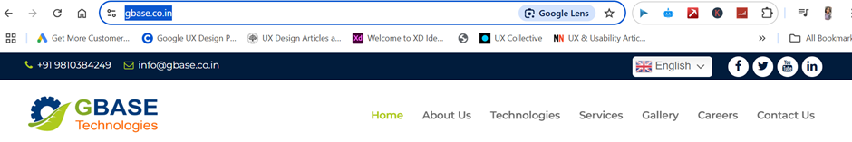

7. Instead of Home & About Us buttons on the top, the following 3 buttons will come:
- Products
- Services ( Subheadings: Projects, Spareparts, Consulting)
- Contact Us
The contact us page can be like this: https://www.urschel.com/contact-sales-rep/
8. When clicking on Spare parts, a page will open containing a form to be filled by the customer. The form will require the following inputs:
Your Name
Company Name
Email ID
Contact No.
Machine Serial No.


Machine Name: ( The customer will choose from the below-mentioned subheadings. The Customer must be able to select them and write their responses. The customer must be able to opt for multiple options.)

OctoFrost | Greefa | Others
᫅ Blancher | ᫅ MSE | ᫅ KUJV
᫅ Chiller | ᫅ Geosort | ᫅ GS10-2
᫅ Shaker | Other, please specify (Must be able to write the name of the other machine) | Other, please specify (Must be able to write the name of the other machine)
᫅ Washer
᫅ Conveyor
Other, please specify (Must be able to write the name of a different machine)
Part No., Part Pictures (Must be able to add pictures) and Quantity Required
A submit button will be there at the end of the page. The responses will be automatically emailed to info@gbase.co.in
Once the form is submitted, the customer will receive an automated display: 'Thank you, we’ve received your response.'



Home Page:
9. Then,
( Image 1.4)
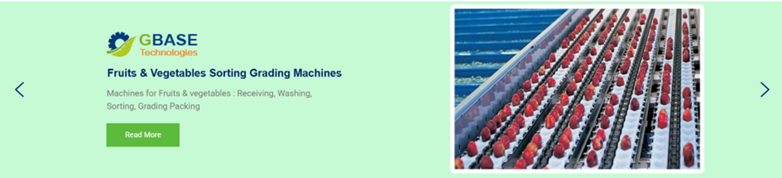
The above section will be divided into the following 2 sections: (Note*- No swiping of slides)
PRODUCTS | SERVICES
Note*: This will cover most of the home page.
10. Attach the GBASE Technologies brochure after that. (We’ll share it with you)
11. Remove the Our Services section ( Image 1.5)
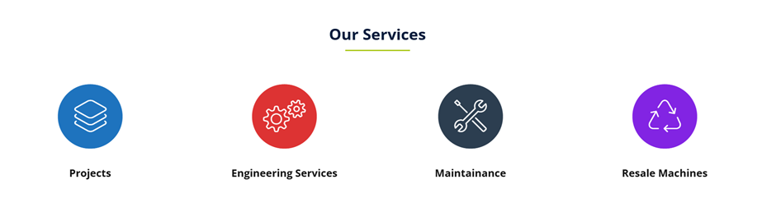

12. Remove Our Work Section ( Refer to image 1.6). Then the product categories will be shown as showcased in the slide.
Instead of our work, the brand logos of our clients will appear. (We’ll share the rest of the clients with you)
Image 1.6
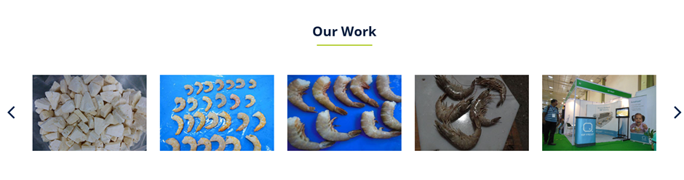
Clientele:
- MZ Foods
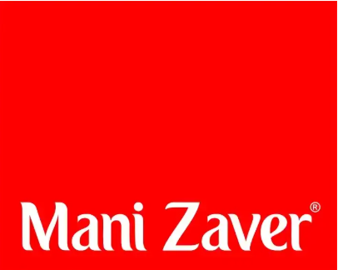

- Indian Frozen Foods

- B Y Agro


- Abad Group


- Cheema Frozen Foods


- Sahyadri Farms


- Haldiram’s



- Prasad Seeds

- Devi Seafoods

- Ziwi Ltd.

- Amalgam Foods




- Febine Marine


- Bio Foods Pvt. Ltd.

- Total Food Processing

- Vashini Agro

- Adani Agri Fresh Ltd




- Farm Fresh



- Fruit Master

- Himalaya Cotton Yarn Limited

- HPMC



- Superfresh Agro



- CRD Foods




- FFT Himalya
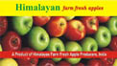

- Flex Food Ltd

- Cargil Foods Company Pvt Ltd

- Kumar Equipment Pvt Ltd

- Foods & Inns



- EssEmm Corporation

- Foodtech Equipments Company
30. MKC Agro Fresh

13. The footer of the page will also include the following 3 headings/buttons:
A. Products ( Subcategories: Freezing, Heating, Round Fruit Sorting)
B. Services
C. Contact Us


14. When the user clicks on the words Freezing Equipment, another page will open:
Octofrost IQF ( Along with the picture of the IQF Line). Attach Octofrost website link: www.octofrost.com
Equipment Products
Pre-Processing Your Products for IQF:
Receiving Vegetables
Washing Fruits
Blanching Seafood
Chilling Dairy
De-watering Bakery
Freezing Meat + Poultry
Sorting
Bulk Packing
Impingement Freezer
Spiral Freezer
Carton Box Freezer
Plate Freezer
Contact Freezer
Blast Freezer
Heating products
Grill
Contact Grills
Oil Fryer
Baking Ovens
Oil Filtration
With every equipment, a picture of the end product and videos of the equipment will be added.
(Note- The customer must be able to opt for multiple options from the subsections of both Equipment and Products)
When the customer clicks on Blanching, blanching videos appear. (Will share it with you)
Note*: This will cover the entire page

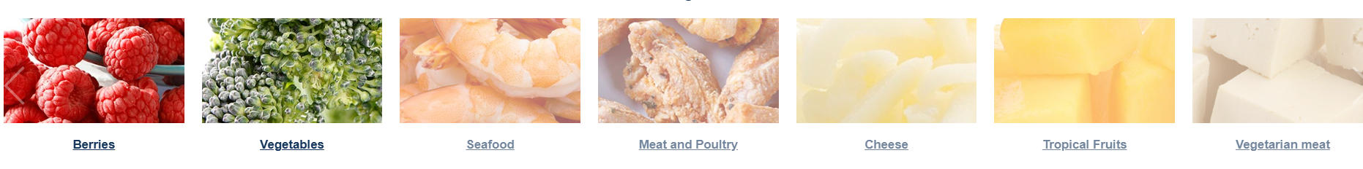

When clicking on the word vegetables, the following subsection will appear:
1. Beans
2. Broccoli
3. Cabbage
4. Carrots
5. Cauliflower
6. Green Peas
7. Leafy Herbs
8. Okra Chillies
9. Onion
10. Potato Dice
11. Sweet Corn
12. Soy
13. Tomato
14. Others, please specify
(Customer must be able to opt for multiple options)
A submit button will be there at the end of the page. When clicked on 'Submit', the responses will be automatically emailed to info@gbase.co.in, along with the customer details: Your Name, Company Name, Country, City, Email, and Cell Phone.


When clicking on the word Fruits, the following subsection will appear:
1. Apple
2. Banana
3. Coconut white
4. Jackfruit
5. Mango
6. Melon
7. Papaya
8. Pineapple
9. Pomegranate
10. Strawberry
11. Others, please specify
(Customer must be able to opt for multiple options)
A submit button will be there at the end of the page. When clicked on 'Submit', the responses will be automatically emailed to info@gbase.co.in, along with the customer details: Your Name, Company Name, Country, City, Email, and Cell Phone.
When clicking on the word Seafood, the following subsection will appear:
- Octopus
- Shrimp
- Squid Rings
- Other, please specify
(Customer must be able to opt for multiple options)
A submit button will be there at the end of the page. When the button 'Submit' is clicked, the responses will be automatically emailed to info@gbase.co.in, along with the customer details: Your Name, Company Name, Country, City, Email, and Cell Phone.

When clicking on the word Dairy, the following subsection will appear:
- Cheese
- Paneer
- Other, please specify
(Customer must be able to opt for multiple options)
A submit button will be there at the end of the page. When clicked on 'Submit', the responses will be automatically emailed to info@gbase.co.in, along with the customer details: Your Name, Company Name, Country, City, Email, and Cell Phone.
When clicking on the word Bakery, the following subsection will appear:
- Bread
- Buns
- Other, please specify
(Customer must be able to opt for multiple options)
A submit button will be there at the end of the page. When the 'Submit' button is clicked, the responses will be automatically emailed to info@gbase.co.in, along with the customer details: Your Name, Company Name, Country, City, Email, and Cell Phone.
When clicking on the word Meat + Poultry, the following subsection will appear:
- Meat
- Chicken
- Pork
- Ham
- Other, please specify
(Customer must be able to opt for multiple options)
A submit button will be there at the end of the page. When clicked on 'Submit', the responses will be automatically emailed to info@gbase.co.in, along with the customer details: Your Name, Company Name, Country, City, Email, and Cell Phone.

14. When the user clicks on the word Round Fruit Sorting, another page will open:
Greefa Round Fruit Sorting
Equipment Crop
Bin Dumping Apples
Selection Avocados
Drying Mangoes
Polishing Oranges
Singulation Others
Sorting
Packing
Storage
(Customer must be able to opt for multiple options)
A submit button will be there at the end of the page. When the button 'Submit' is clicked, the responses will be automatically emailed to info@gbase.co.in, along with the customer details: Your Name, Company Name, Country, City, Email, and Cell Phone.
With every equipment, a picture of the end product and videos of the equipment will be added.


—------------------------------------—------------THANKYOU!------------------------------------------------------

